Ex.no:2 | EDA-DATA IMPORT AND EXPORT

Aim:
To inspect dataset features, detect null values, and export data into CSV, Excel, and SQLite database formats.
Algorithm:
- Import pandas and sqlite3 libraries.
- Read hotel_bookings.csv using pd.read_csv().
- Inspect data structure using .head(), .tail(), .info(), .describe(), and .isnull().sum().
- Export DataFrame to .csv and .xlsx formats using .to_csv() and .to_excel().
- Connect to hotel_booking.db using sqlite3 and write data into an SQL table via .to_sql().
- Close the database connection and end execution.

Program:
# Import required libraries
import pandas as pd
# Load the Hotel Booking dataset
df=pd.read_csv('Sleep_health_and_lifestyle_dataset.csv')
# Display the complete dataset
print(df)
# Display first five records
print(df.head())
# Display dataset information
print(df.info())
# Display statistical summary
print(df.describe())
!pip install openpyxl
df = pd.read_csv("Sleep_health_and_lifestyle_dataset.csv") df.to_excel("Sleep_health_and_lifestyle_dataset.xlsx", index=False) print("Excel file created successfully.")
df_excel = pd.read_excel("Sleep_health_and_lifestyle_dataset.xlsx") print(df_excel.head())
import sqlite3

df = pd.read_csv("Sleep_health_and_lifestyle_dataset.csv") conn = sqlite3.connect("sleep_health.db") df.to_sql("sleep_data", conn, if_exists="replace", index=False) print("Data imported into SQL successfully!")
query = "SELECT * FROM sleep_data" df_sql = pd.read_sql(query, conn) print(df_sql.head())
url=”Sleep_health_and_lifestyle_dataset.csv”
df=pd.read_csv(url)
print(df.head())
df = pd.read_csv("Sleep_health_and_lifestyle_dataset.csv") df.to_csv("Sleep_Output.csv", index=False)
print("CSV File Exported Successfully")
df = pd.read_csv("Sleep_health_and_lifestyle_dataset.csv") df.to_excel("Sleep_Output.xlsx", index=False) print("Excel File Exported")
df = pd.read_csv("Sleep_health_and_lifestyle_dataset.csv") df.to_json("Sleep_Output.json", orient="records") print("JSON File Exported")
import matplotlib.pyplot as plt

df=pd.read_csv("Sleep_health_and_lifestyle_dataset.csv") occupation_count = df["Occupation"].value_counts() occupation_count.plot(kind="bar", figsize=(10,5)) plt.title("Number of Participants by Occupation") plt.xlabel("Occupation")
plt.ylabe("Count")
plt.show(
Output:
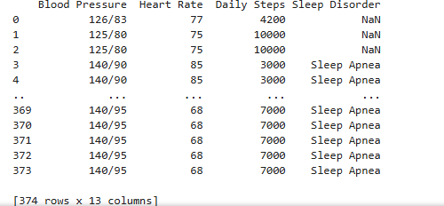
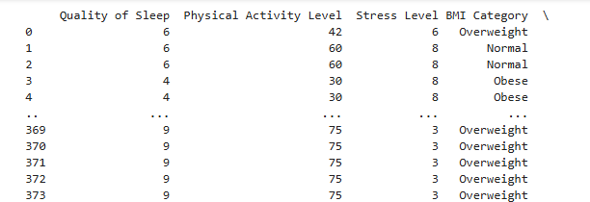
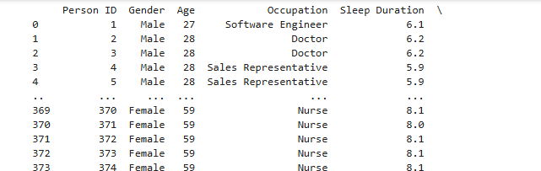
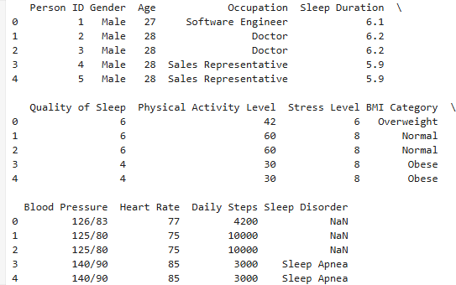
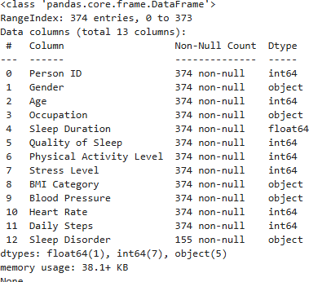
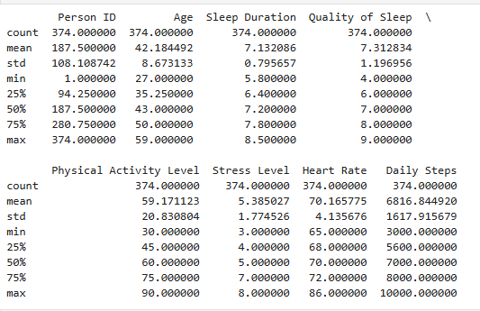
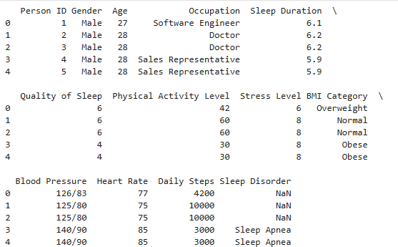
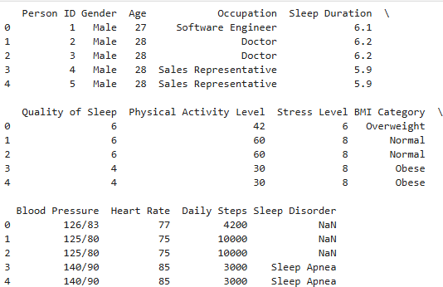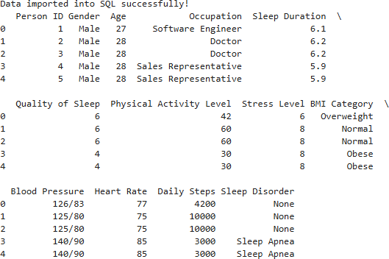

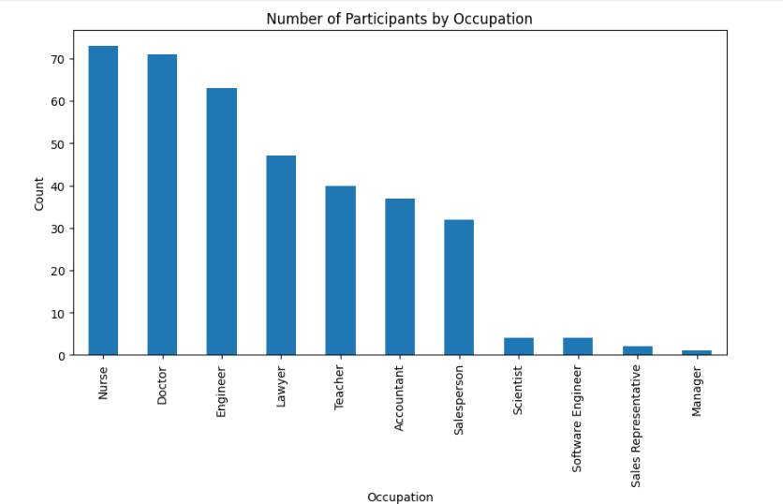

Result:

